User Manual for Studio 2



# Contents Page

Contents Page 2

1. Hardware and Software Requirements 3

2. System Security 3

2.1. Virus Protection: 3

2.2. Password Protection: 3

2.3. Back-Ups: 3

3. Installation Guide 4

3.1. Program: 4

3.2. SQL Server Back-up: 5

4. Step by step operating instructions all aspects of the system 8

4.1. Member Tab 8

4.2. Exercise Class Tab 10

4.3. Booking Tab 12

4.4. Payment Tab 14

4.5. Room Tab 16

4.6. Room Hire Tab 18

4.7. Employee Tab 20

4.8. External Company Tab 22

4.9. Payment Method Tab 24

4.10. Staff Qualification Tab 26

4.11. Qualification Tab 28

5. Back up Procedures 30

6. Error Handling 34

7. Further Help and Support 36

# Hardware and Software Requirements

|  |  |  |
| --- | --- | --- |
| Component | Minimum | Recommended |
| Processor | 1.80 GHz or faster | 2.0GHz or faster |
| RAM | 4GB | 8GB |
| HDD | 50GB | 250GB |
| Screen Resolution | 1366 x 768 | 1920 x 1080 |
| Operating System | Windows 7 | Windows 8.1 |
| .Net environment | Visual Studio 2013 Express | Visual Studio 2014 Professional |
| SQL Server Management Version | SQL Server Management Version 2012 | SQL Server Management Version 2014 |

# System Security

## Virus Protection:

* You should protect the system using anti-virus and anti-malware software (e.g. Norton, McAfee, AVG etc.).
* Virus definitions should be kept up-to-date.
* Scans should be run daily.
* In the event of an intrusion, run the anti-virus/anti-malware software. If the infection is not resolved, restore the system from the most recent back-up.

## Password Protection:

* This system is protected by a password.
* The current password is Password1
* The password is requested at the starting of the system.
* Passwords should be at least 8 characters and contain at least one number.
* Passwords can be changed by the user (see further in the manual).

## Back-Ups:

* You should back-up the database daily (see Section 6: Back-Up Procedures).
* A back-up of the Studio 2 software and database should be kept off-site in case of fire, theft etc.

# Installation Guide

In order for the program to work Microsoft Visual Studio and Microsoft SQL Server Management Studio must be installed.

## Program:

1. Open the folder that the program is stored in.

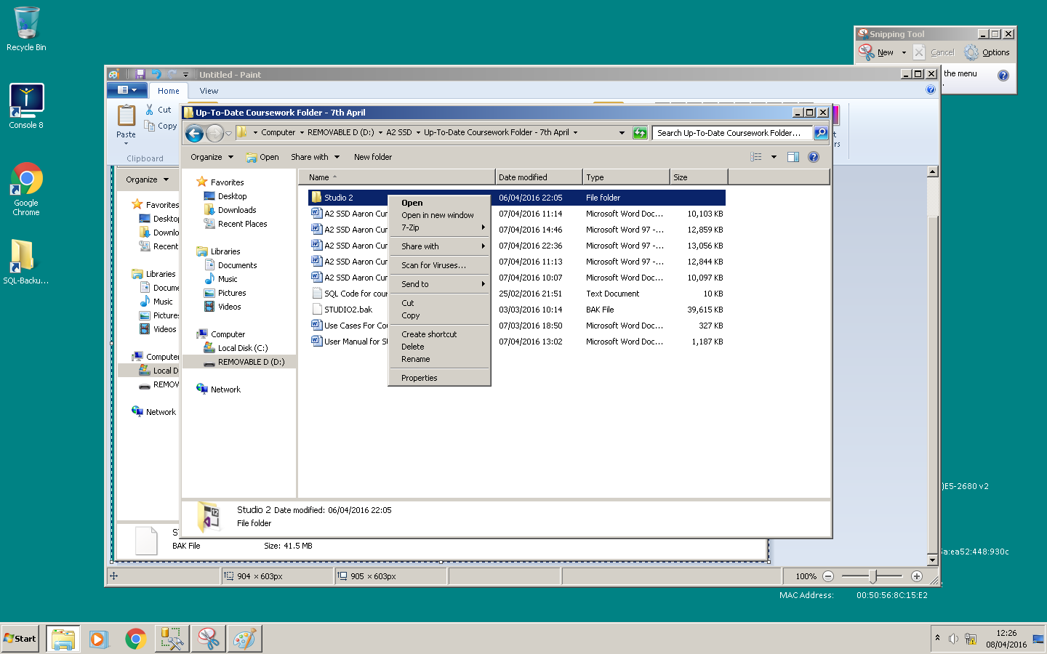

1. 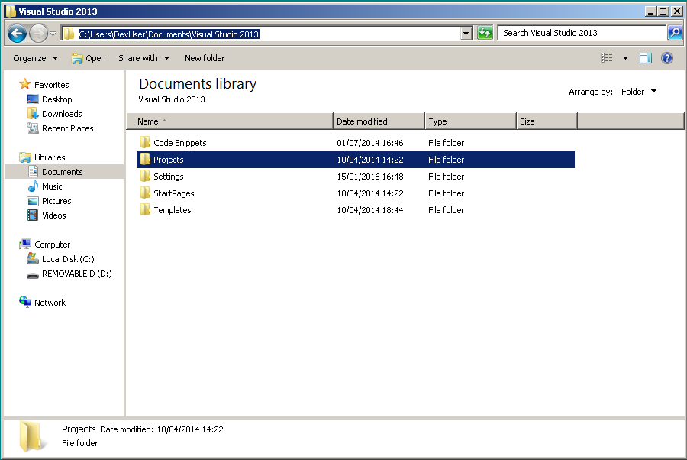Copy folder to the Visual Studio Projects Folder

## SQL Server Back-up:

1. 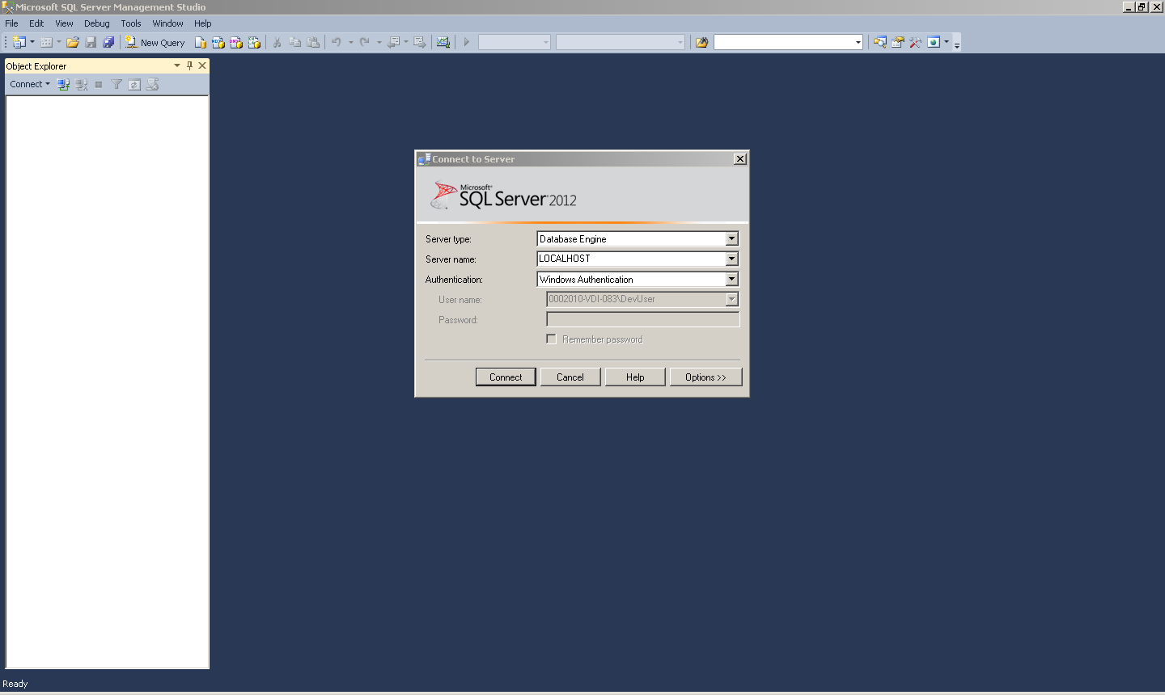Open SQL Server Management Studio
2. Connect to the Server and expand the databases tab and select restore database.

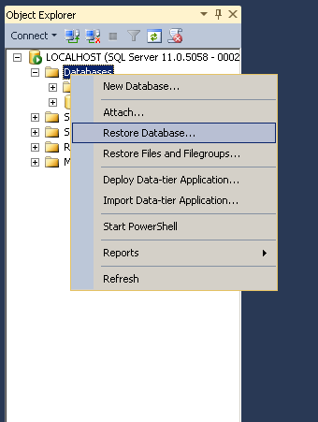

1. Select the device you wish to restore from by pressing the browse button on the right

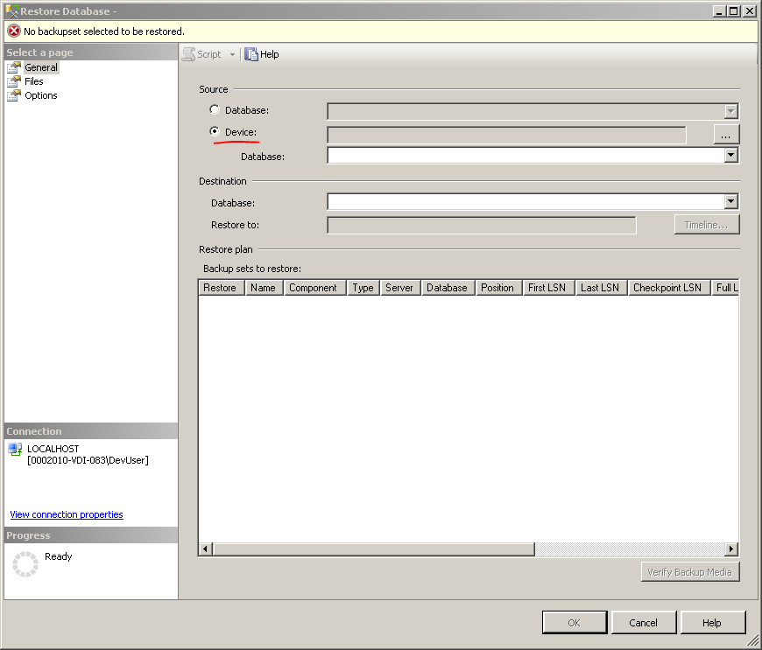

1. Click Add and then select the folder you want to restore from.

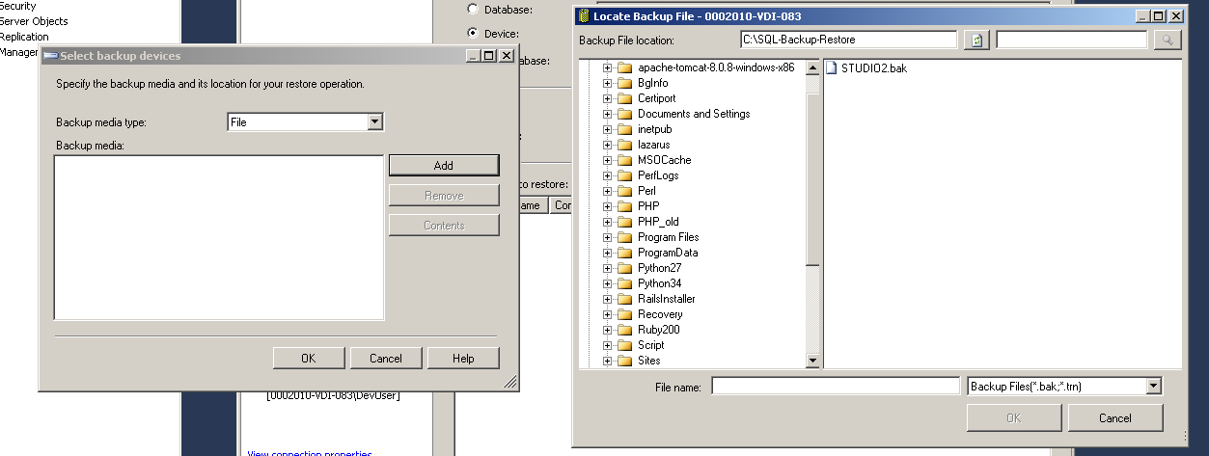

1. Press Add and the database should be restored.

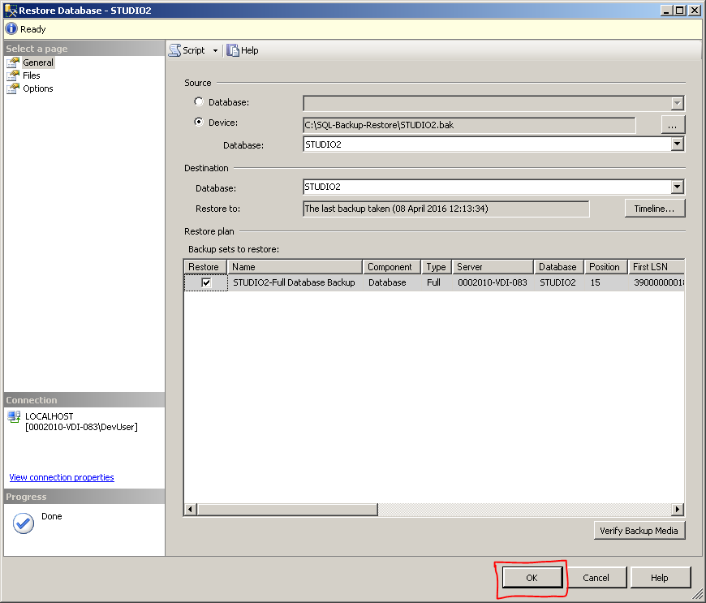

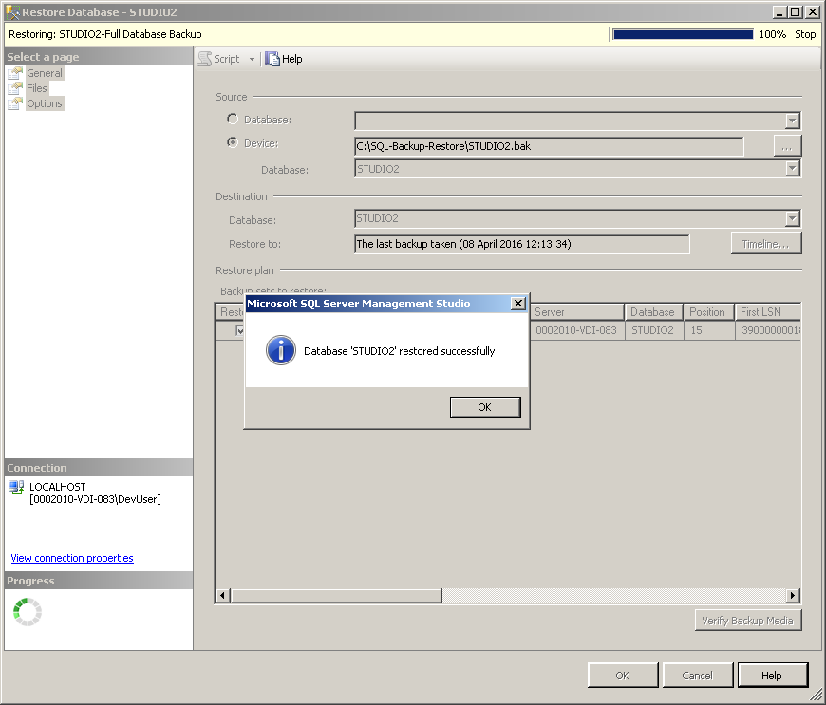

# Step by step operating instructions all aspects of the system

# Member Tab

## The member tab is designed to allow Studio 2 employees to:

* Add Members – add a new member to Studio 2 member database.
* Update Members – update record details for an existing Studio member.
* Delete Members – delete an existing Studio 2 member record.
* Search for Members – search for an existing Studio 2 member’s record details.

## Members Tab Layout

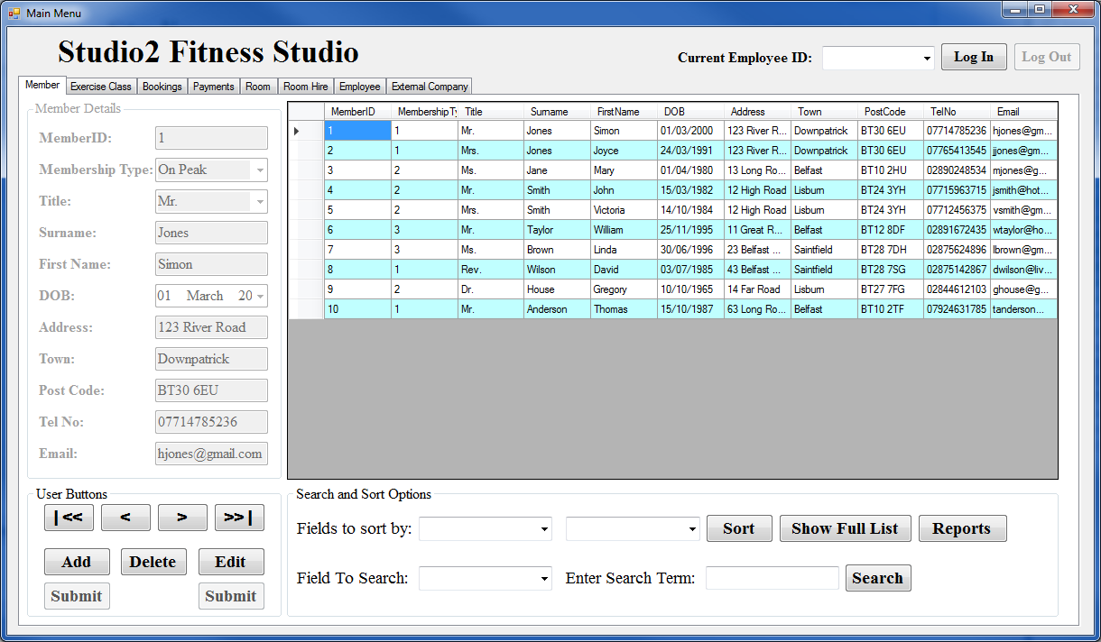

# How to Add a New Member

1. Click the **Add** button.
2. Select the Membership Type and Title from the drop down list
3. Fill in Surname, First Name, DOB, Address, Town, Post Code, Telephone Number and Email Address.
4. Click **Submit** button under the add button.

## What happens when I click Submit?

* If the member data input passes the validation checks, the member record will then be **added** to the Studio 2 database and the new member record will be displayed in the onscreen membership list.
* If the member data input does not pass the data validation checks, on screen help messages will appear, asking you to correct the data.
* You must correct the data entry errors and click **Submit** again.

# How to Delete a Member

1. Bring their details on screen (i.e. so the details occupy the form)
2. Click the **Delete** button.
3. Confirm that that is what you wish to do.

# How to Edit/Update a Member

1. Bring their details on screen (i.e. so the details occupy the form)
2. Click the **Edit** button.
3. Change the details that require editing.
4. Click **Submit** button under the Edit button.

# How to Sort the Members List

1. Select the field by which you want to sort by from the drop down list
2. Select the order of the list from the drop down list
3. Click the **Sort** button.

# How to Search the Members List

1. Select the field by which you want to search by from the drop down list
2. Enter the term you want to search for (e.g. if searching surname enter their surname)
3. Click the **Search** button.

# How to Show All of the Members List

1. Click the **Show Full List** button.

# How Create a Report of the Members List

1. Click the **Reports** button.

# Exercise Class Tab

## The Exercise Class tab is designed to allow Studio 2 employees to:

* Add Exercise Classes – add a new Exercise Class to Studio 2 Exercise Class database.
* Update Exercise Classes – update record details for an existing Studio Exercise Class.
* Delete Exercise Classes – delete an existing Studio 2 Exercise Class record.
* Search for Exercise Classes – search for an existing Studio 2 Exercise Class’s record details.

## Exercise Classs Tab Layout

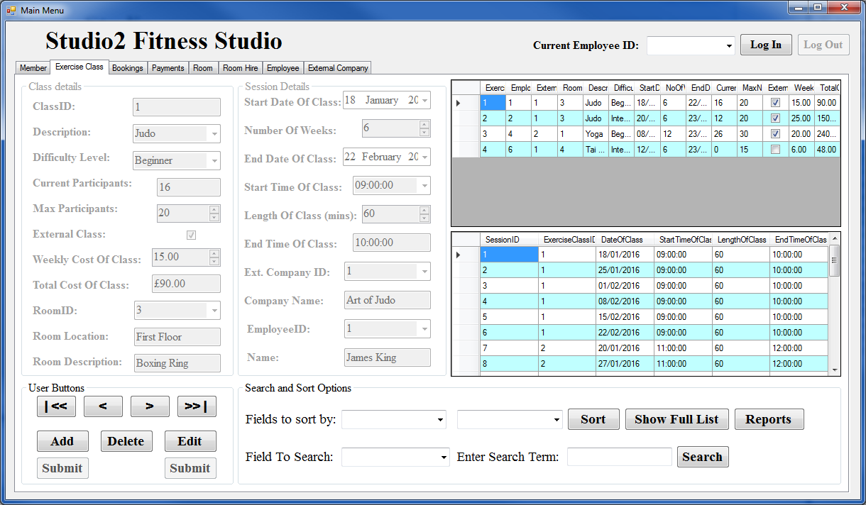

# How to Add a New Exercise Class

1. Click the **Add** button.
2. Select the Description and Difficulty Level from the drop down lists.
3. Fill in the maximum number of participants allowed, if it is an External Company and how much the class costs per week.
4. Select the room which the class will happen in from the drop down list.
5. Enter the Start Date, number of weeks, start time and length of the class.
6. If the class is run externally, select which company is running the class.
7. Select the Employee ID of the employee that is running the class.
8. Click **Submit** button under the add button.

## What happens when I click Submit?

* If the Exercise Class data input passes the validation checks, the Exercise Class record will then be **added** to the Studio 2 database and the new Exercise Class record will be displayed in the onscreen Exercise Classes list.
* If the Exercise Class data input does not pass the data validation checks, on screen help messages will appear, asking you to correct the data.
* You must correct the data entry errors and click **Submit** again.

# How to Delete an Exercise Class

1. Bring their details on screen (i.e. so the details occupy the form)
2. Click the **Delete** button.
3. Confirm that that is what you wish to do.

# How to Edit/Update an Exercise Class

1. Bring their details on screen (i.e. so the details occupy the form)
2. Click the **Edit** button.
3. Change the details that require editing.
4. Click **Submit** button under the Edit button.

# How to Sort the Exercise Classes List

1. Select the field by which you want to sort by from the drop down list
2. Select the order of the list from the drop down list
3. Click the **Sort** button.

# How to Search the Exercise Classes List

1. Select the field by which you want to search by from the drop down list
2. Enter the term you want to search for (e.g. if searching surname enter their surname)
3. Click the **Search** button.

# How to Show All of the Exercise Classes List

1. Click the **Show Full List** button.

# How Create a Report of the Exercise Classes List

1. Click the **Reports** button.

# Booking Tab

## The Booking tab is designed to allow Studio 2 employees to:

* Add Bookings – add a new Booking to Studio 2 Booking database.
* Update Bookings – update record details for an existing Studio Booking.
* Delete Bookings – delete an existing Studio 2 Booking record.
* Search for Bookings – search for an existing Studio 2 Booking’s record details.

## Bookings Tab Layout

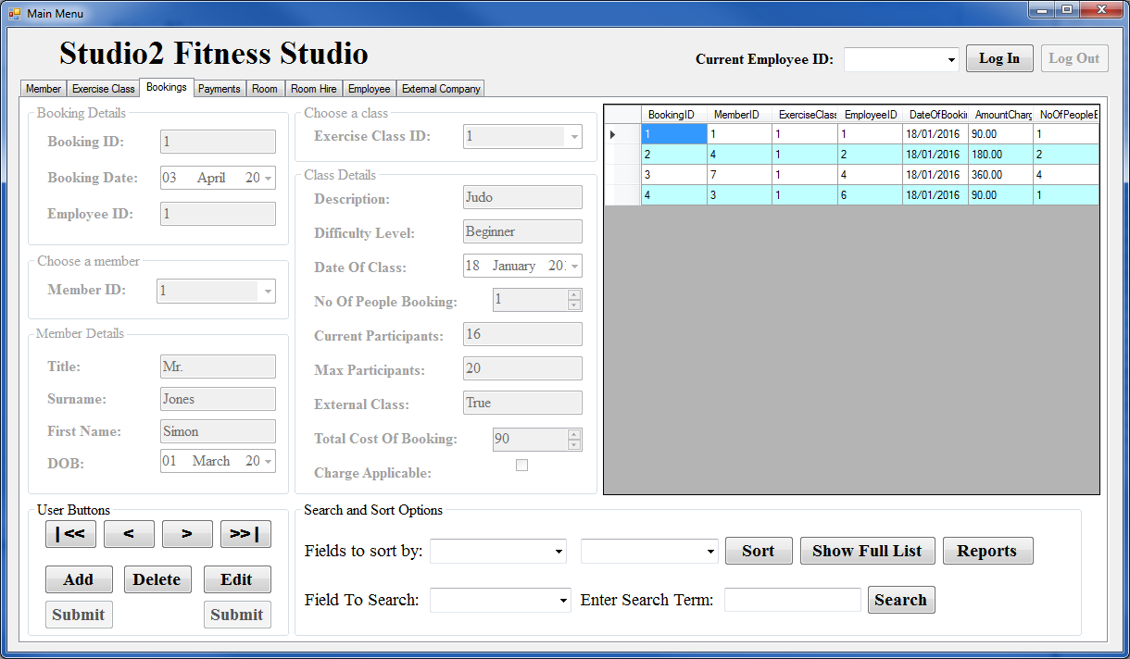

# How to Add a New Booking

1. Click the **Add** button.
2. Select the Member ID and the Exercise Class ID from the drop down lists.
3. Fill in the number of people booking.
4. If it is all members the charge is not applicable and so the charge applicable should be unchecked. Increase the total cost to the necessary amount (i.e. set to the number of non-members)
5. Click **Submit** button under the add button.

## What happens when I click Submit?

* If the Booking data input passes the validation checks, the Booking record will then be **added** to the Studio 2 database and the new Booking record will be displayed in the onscreen Bookings list.
* If the Booking data input does not pass the data validation checks, on screen help messages will appear, asking you to correct the data.
* You must correct the data entry errors and click **Submit** again.

# How to Delete an Booking

1. Bring their details on screen (i.e. so the details occupy the form)
2. Click the **Delete** button.
3. Confirm that that is what you wish to do.

# How to Edit/Update an Booking

1. Bring their details on screen (i.e. so the details occupy the form)
2. Click the **Edit** button.
3. Change the details that require editing.
4. Click **Submit** button under the Edit button.

# How to Sort the Bookings List

1. Select the field by which you want to sort by from the drop down list
2. Select the order of the list from the drop down list
3. Click the **Sort** button.

# How to Search the Bookings List

1. Select the field by which you want to search by from the drop down list
2. Enter the term you want to search for (e.g. if searching surname enter their surname)
3. Click the **Search** button.

# How to Show All of the Bookings List

1. Click the **Show Full List** button.

# How Create a Report of the Bookings List

1. Click the **Reports** button.

# Payment Tab

## The Payment tab is designed to allow Studio 2 employees to:

* Add Payments – add a new Payment to Studio 2 Payment database.
* Update Payments – update record details for an existing Studio Payment.
* Delete Payments – delete an existing Studio 2 Payment record.
* Search for Payments – search for an existing Studio 2 Payment’s record details.

## Payments Tab Layout

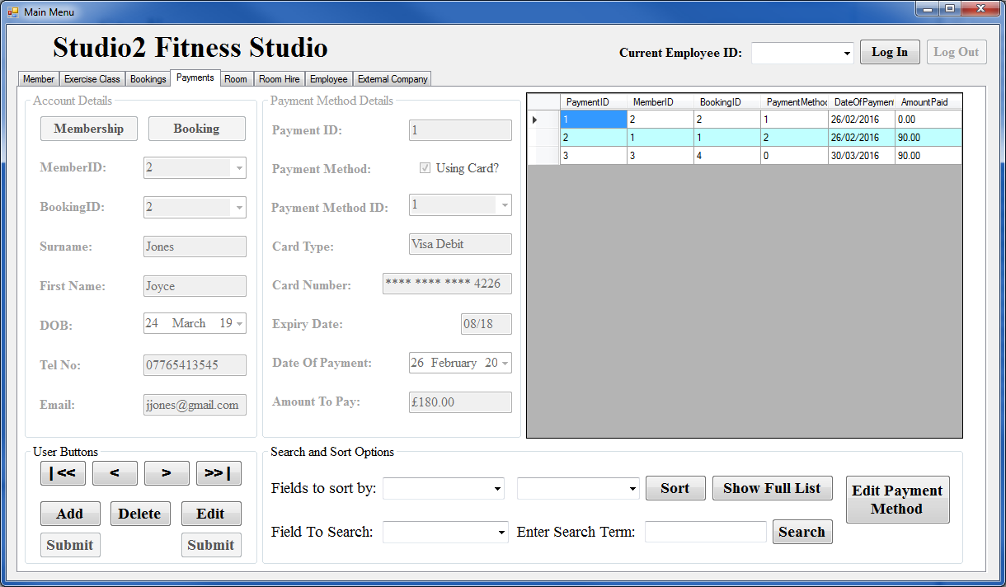

# How to Add a New Payment

1. Click the **Add** button.
2. Select the Member ID and the Booking ID from the drop down lists.
3. Select if the Member is paying with card.
4. If they are, select their Payment Method of choice
5. If it is all members the charge is not applicable and so the charge applicable should be unchecked. Increase the total cost to the necessary amount (i.e. set to the number of non-members)
6. Click **Submit** button under the add button.

## What happens when I click Submit?

* If the Payment data input passes the validation checks, the Payment record will then be **added** to the Studio 2 database and the new Payment record will be displayed in the onscreen Payments list.
* If the Payment data input does not pass the data validation checks, on screen help messages will appear, asking you to correct the data.
* You must correct the data entry errors and click **Submit** again.

# How to Delete an Payment

1. Bring their details on screen (i.e. so the details occupy the form)
2. Click the **Delete** button.
3. Confirm that that is what you wish to do.

# How to Edit/Update an Payment

1. Bring their details on screen (i.e. so the details occupy the form)
2. Click the **Edit** button.
3. Change the details that require editing.
4. Click **Submit** button under the Edit button.

# How to Sort the Payments List

1. Select the field by which you want to sort by from the drop down list
2. Select the order of the list from the drop down list
3. Click the **Sort** button.

# How to Search the Payments List

1. Select the field by which you want to search by from the drop down list
2. Enter the term you want to search for (e.g. if searching surname enter their surname)
3. Click the **Search** button.

# How to Show All of the Payments List

1. Click the **Show Full List** button.

# Room Tab

## The Room tab is designed to allow Studio 2 employees to:

* Add Rooms – add a new Room to Studio 2 Room database.
* Update Rooms – update record details for an existing Studio Room.
* Delete Rooms – delete an existing Studio 2 Room record.
* Search for Rooms – search for an existing Studio 2 Room’s record details.

## Rooms Tab Layout

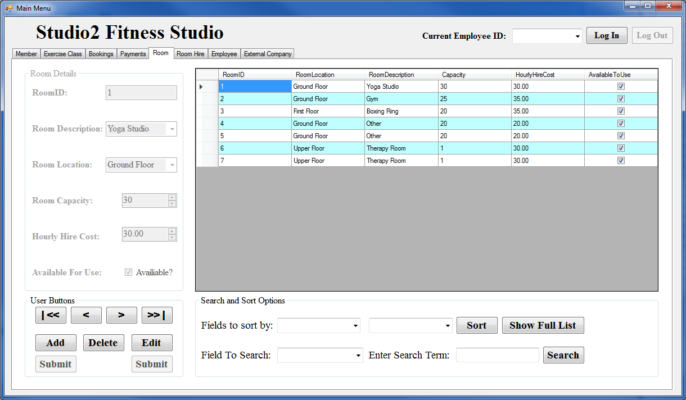

# How to Add a New Room

1. Click the **Add** button.
2. Select the Description and the Location from the drop down lists.
3. Using the arrows at the side or by typing the number in enter the room capacity and hourly hire cost.
4. Select if the room is available for use.
5. Click **Submit** button under the add button.

## What happens when I click Submit?

* If the Room data input passes the validation checks, the Room record will then be **added** to the Studio 2 database and the new Room record will be displayed in the onscreen Rooms list.
* If the Room data input does not pass the data validation checks, on screen help messages will appear, asking you to correct the data.
* You must correct the data entry errors and click **Submit** again.

# How to Delete an Room

1. Bring their details on screen (i.e. so the details occupy the form)
2. Click the **Delete** button.
3. Confirm that that is what you wish to do.

# How to Edit/Update an Room

1. Bring their details on screen (i.e. so the details occupy the form)
2. Click the **Edit** button.
3. Change the details that require editing.
4. Click **Submit** button under the Edit button.

# How to Sort the Rooms List

1. Select the field by which you want to sort by from the drop down list
2. Select the order of the list from the drop down list
3. Click the **Sort** button.

# How to Search the Rooms List

1. Select the field by which you want to search by from the drop down list
2. Enter the term you want to search for (e.g. if searching surname enter their surname)
3. Click the **Search** button.

# How to Show All of the Rooms List

1. Click the **Show Full List** button.

# Room Hire Tab

## The Room Hire tab is designed to allow Studio 2 employees to:

* Add Room Hires – add a new Room Hire to Studio 2 Room Hire database.
* Update Room Hires – update record details for an existing Studio Room Hire.
* Delete Room Hires – delete an existing Studio 2 Room Hire record.
* Search for Room Hires – search for an existing Studio 2 Room Hire’s record details.

## Room Hire Tab Layout

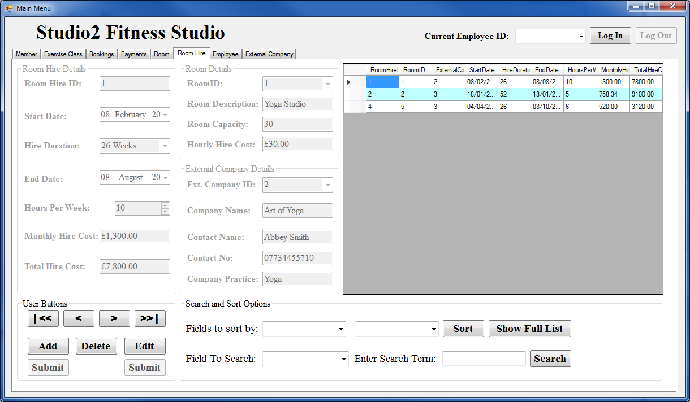

# How to Add a New Room Hire

1. Click the **Add** button.
2. Select the Start Date from the date time picker and the hire duration from the drop down list.
3. Using the arrows at the side or by typing the number in enter the hours per week they want to rent the room for.
4. Select the Room ID and the External Company ID from the drop down lists.
5. Click **Submit** button under the add button.

## What happens when I click Submit?

* If the Room Hire data input passes the validation checks, the Room Hire record will then be **added** to the Studio 2 database and the new Room Hire record will be displayed in the onscreen Room Hires list.
* If the Room Hire data input does not pass the data validation checks, on screen help messages will appear, asking you to correct the data.
* You must correct the data entry errors and click **Submit** again.

# How to Delete an Room Hire

1. Bring their details on screen (i.e. so the details occupy the form)
2. Click the **Delete** button.
3. Confirm that that is what you wish to do.

# How to Edit/Update an Room Hire

1. Bring their details on screen (i.e. so the details occupy the form)
2. Click the **Edit** button.
3. Change the details that require editing.
4. Click **Submit** button under the Edit button.

# How to Sort the Room Hires List

1. Select the field by which you want to sort by from the drop down list
2. Select the order of the list from the drop down list
3. Click the **Sort** button.

# How to Search the Room Hires List

1. Select the field by which you want to search by from the drop down list
2. Enter the term you want to search for (e.g. if searching surname enter their surname)
3. Click the **Search** button.

# How to Show All of the Room Hires List

1. Click the **Show Full List** button.

# Employee Tab

## The Employee tab is designed to allow Studio 2 employees to:

* Add Employees – add a new Employee to Studio 2 Employee database.
* Update Employees – update record details for an existing Studio Employee.
* Delete Employees – delete an existing Studio 2 Employee record.
* Search for Employees – search for an existing Studio 2 Employee’s record details.

## Employees Tab Layout

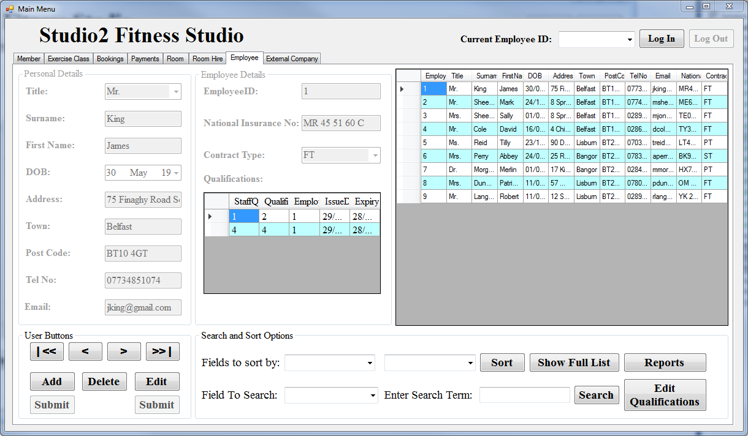

# How to Add a New Employee

1. Click the **Add** button.
2. Select the Title and the Contract Type from the drop down list
3. Fill in Surname, First Name, DOB, Address, Town, Post Code, Telephone Number, Email Address and National Insurance Number.
4. Select if the Employee is available for use.
5. Click **Submit** button under the add button.

## What happens when I click Submit?

* If the Employee data input passes the validation checks, the Employee record will then be **added** to the Studio 2 database and the new Employee record will be displayed in the onscreen Employees list.
* If the Employee data input does not pass the data validation checks, on screen help messages will appear, asking you to correct the data.
* You must correct the data entry errors and click **Submit** again.

# How to Delete an Employee

1. Bring their details on screen (i.e. so the details occupy the form)
2. Click the **Delete** button.
3. Confirm that that is what you wish to do.

# How to Edit/Update an Employee

1. Bring their details on screen (i.e. so the details occupy the form)
2. Click the **Edit** button.
3. Change the details that require editing.
4. Click **Submit** button under the Edit button.

# How to Sort the Employees List

1. Select the field by which you want to sort by from the drop down list
2. Select the order of the list from the drop down list
3. Click the **Sort** button.

# How to Search the Employees List

1. Select the field by which you want to search by from the drop down list
2. Enter the term you want to search for (e.g. if searching surname enter their surname)
3. Click the **Search** button.

# How to Show All of the Employees List

1. Click the **Show Full List** button.

# How Create a Report of the Employees List

1. Click the **Reports** button.

# External Company Tab

## The External Company tab is designed to allow Studio 2 employees to:

* Add External Companies – add a new External Company to Studio 2 External Company database.
* Update External Companies – update record details for an existing Studio External Company.
* Delete External Companies – delete an existing Studio 2 External Company record.
* Search for External Companies – search for an existing Studio 2 External Company’s record details.

## External Companies Tab Layout

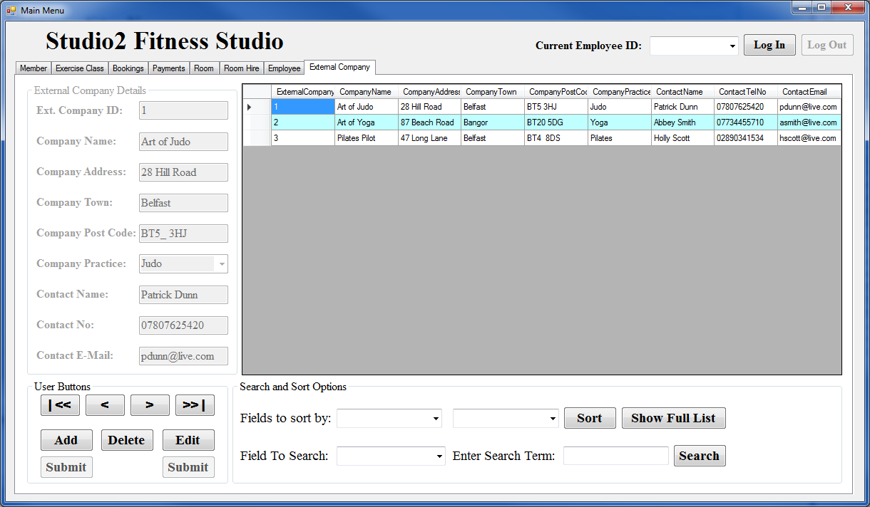

# How to Add a New External Company

1. Click the **Add** button.
2. Enter the Company's details and their contact details in the textboxes provided.
3. Select the Company Practice from the drop down list.
4. Click **Submit** button under the add button.

## What happens when I click Submit?

* If the External Company data input passes the validation checks, the External Company record will then be **added** to the Studio 2 database and the new External Company record will be displayed in the onscreen External Companies list.
* If the External Company data input does not pass the data validation checks, on screen help messages will appear, asking you to correct the data.
* You must correct the data entry errors and click **Submit** again.

# How to Delete an External Company

1. Bring their details on screen (i.e. so the details occupy the form)
2. Click the **Delete** button.
3. Confirm that that is what you wish to do.

# How to Edit/Update an External Company

1. Bring their details on screen (i.e. so the details occupy the form)
2. Click the **Edit** button.
3. Change the details that require editing.
4. Click **Submit** button under the Edit button.

# How to Sort the External Companies List

1. Select the field by which you want to sort by from the drop down list
2. Select the order of the list from the drop down list
3. Click the **Sort** button.

# How to Search the External Companies List

1. Select the field by which you want to search by from the drop down list
2. Enter the term you want to search for (e.g. if searching surname enter their surname)
3. Click the **Search** button.

# How to Show All of the External Companies List

1. Click the **Show Full List** button.

# Payment Method Tab

## The Payment Method tab is designed to allow Studio 2 employees to:

* Add Payment Methods – add a new Payment Method to Studio 2 Payment Method database.
* Update Payment Methods – update record details for an existing Studio Payment Method.
* Delete Payment Methods – delete an existing Studio 2 Payment Method record.
* Search for Payment Methods – search for an existing Studio 2 Payment Method’s record details.

## Payment Methods Tab Layout

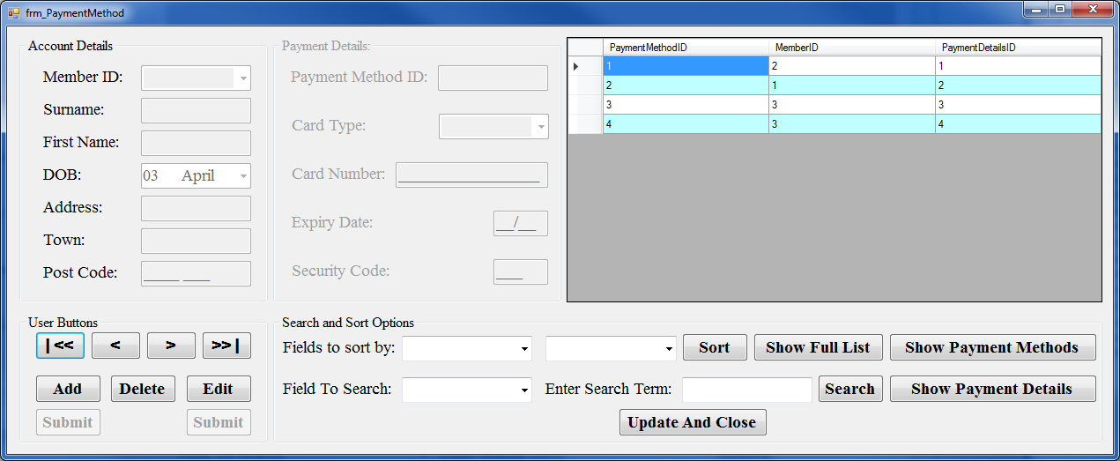

# How to open the Payment Method Tab

1. Select the **Payment Tab**.
2. Click the **Edit Payment Methods** Button.

# How to Add a New Payment Method

1. Click the **Add** button.
2. Select the Member ID of the member who is creating a new payment method and the type of card they are using from the drop down lists.
3. Enter the rest of the card details in the areas provided.
4. Click **Submit** button under the add button.

## What happens when I click Submit?

* If the Payment Method data input passes the validation checks, the Payment Method record will then be **added** to the Studio 2 database and the new Payment Method record will be displayed in the onscreen Payment Methods list.
* If the Payment Method data input does not pass the data validation checks, on screen help messages will appear, asking you to correct the data.
* You must correct the data entry errors and click **Submit** again.

# How to Delete an Payment Method

1. Bring their details on screen (i.e. so the details occupy the form)
2. Click the **Delete** button.
3. Confirm that that is what you wish to do.

# How to Edit/Update an Payment Method

1. Bring their details on screen (i.e. so the details occupy the form)
2. Click the **Edit** button.
3. Change the details that require editing.
4. Click **Submit** button under the Edit button.

# How to Sort the Payment Methods List

1. Select the field by which you want to sort by from the drop down list
2. Select the order of the list from the drop down list
3. Click the **Sort** button.

# How to Search the Payment Methods List

1. Select the field by which you want to search by from the drop down list
2. Enter the term you want to search for (e.g. if searching surname enter their surname)
3. Click the **Search** button.

# How to Show All of the Payment Methods List

1. Click the **Show Full List** button.

# How to return to the main screen

1. Click the **Update and Close** button.

# Staff Qualification Tab

## The Staff Qualification tab is designed to allow Studio 2 employees to:

* Add Staff Qualifications – add a new Staff Qualification to Studio 2 Staff Qualification database.
* Update Staff Qualifications – update record details for an existing Studio Staff Qualification.
* Delete Staff Qualifications – delete an existing Studio 2 Staff Qualification record.
* Search for Staff Qualifications – search for an existing Studio 2 Staff Qualification’s record details.

## Staff Qualifications Tab Layout

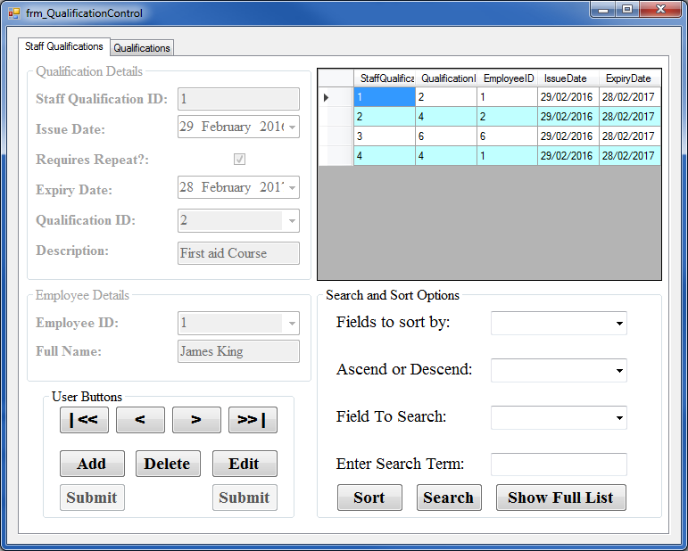

# How to open the Staff Qualification Tab

1. Select the **Employee Tab**.
2. Click the **Edit Qualifications** Button.

# How to Add a New Staff Qualification

1. Click the **Add** button.
2. Select the Issue date from the date time picker.
3. If the course requires a repeat, check the box.
4. If it does, select the Expiry Date. Else proceed to next step.
5. Select the Qualification ID from the drop down list.
6. Click **Submit** button under the add button.

## What happens when I click Submit?

* If the Staff Qualification data input passes the validation checks, the Staff Qualification record will then be **added** to the Studio 2 database and the new Staff Qualification record will be displayed in the onscreen Staff Qualifications list.
* If the Staff Qualification data input does not pass the data validation checks, on screen help messages will appear, asking you to correct the data.
* You must correct the data entry errors and click **Submit** again.

# How to Delete an Staff Qualification

1. Bring their details on screen (i.e. so the details occupy the form)
2. Click the **Delete** button.
3. Confirm that that is what you wish to do.

# How to Edit/Update an Staff Qualification

1. Bring their details on screen (i.e. so the details occupy the form)
2. Click the **Edit** button.
3. Change the details that require editing.
4. Click **Submit** button under the Edit button.

# How to Sort the Staff Qualifications List

1. Select the field by which you want to sort by from the drop down list
2. Select the order of the list from the drop down list
3. Click the **Sort** button.

# How to Search the Staff Qualifications List

1. Select the field by which you want to search by from the drop down list
2. Enter the term you want to search for (e.g. if searching surname enter their surname)
3. Click the **Search** button.

# How to Show All of the Staff Qualifications List

1. Click the **Show Full List** button.

# How to Return to the Main Screen

1. Close the form.

# Qualification Tab

## The Qualification tab is designed to allow Studio 2 employees to:

* Add Qualifications – add a new Qualification to Studio 2 Qualification database.
* Update Qualifications – update record details for an existing Studio Qualification.
* Delete Qualifications – delete an existing Studio 2 Qualification record.
* Search for Qualifications – search for an existing Studio 2 Qualification’s record details.

## Qualifications Tab Layout

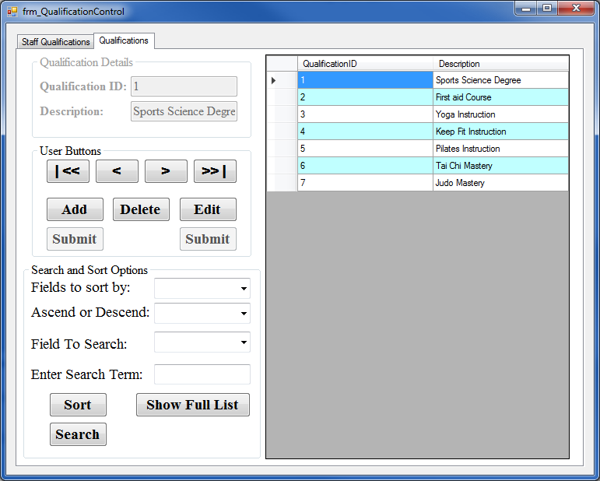

# How to open the Qualification Tab

1. Select the **Employee Tab**.
2. Click the **Edit Qualifications** Button.
3. Select the **Qualifications** Tab

# How to Add a New Qualification

1. Click the **Add** button.
2. Enter the Description into the text box.
3. Click **Submit** button under the add button.

## What happens when I click Submit?

* If the Qualification data input passes the validation checks, the Qualification record will then be **added** to the Studio 2 database and the new Qualification record will be displayed in the onscreen Qualifications list.
* If the Qualification data input does not pass the data validation checks, on screen help messages will appear, asking you to correct the data.
* You must correct the data entry errors and click **Submit** again.

# How to Delete an Qualification

1. Bring their details on screen (i.e. so the details occupy the form)
2. Click the **Delete** button.
3. Confirm that that is what you wish to do.

# How to Edit/Update an Qualification

1. Bring their details on screen (i.e. so the details occupy the form)
2. Click the **Edit** button.
3. Change the details that require editing.
4. Click **Submit** button under the Edit button.

# How to Sort the Qualifications List

1. Select the field by which you want to sort by from the drop down list
2. Select the order of the list from the drop down list
3. Click the **Sort** button.

# How to Search the Qualifications List

1. Select the field by which you want to search by from the drop down list
2. Enter the term you want to search for (e.g. if searching surname enter their surname)
3. Click the **Search** button.

# How to Show All of the Qualifications List

1. Click the **Show Full List** button.

# How to Return to the Main Screen

1. Close the form.

# Back up Procedures

1. Open SQL Server Management Studio

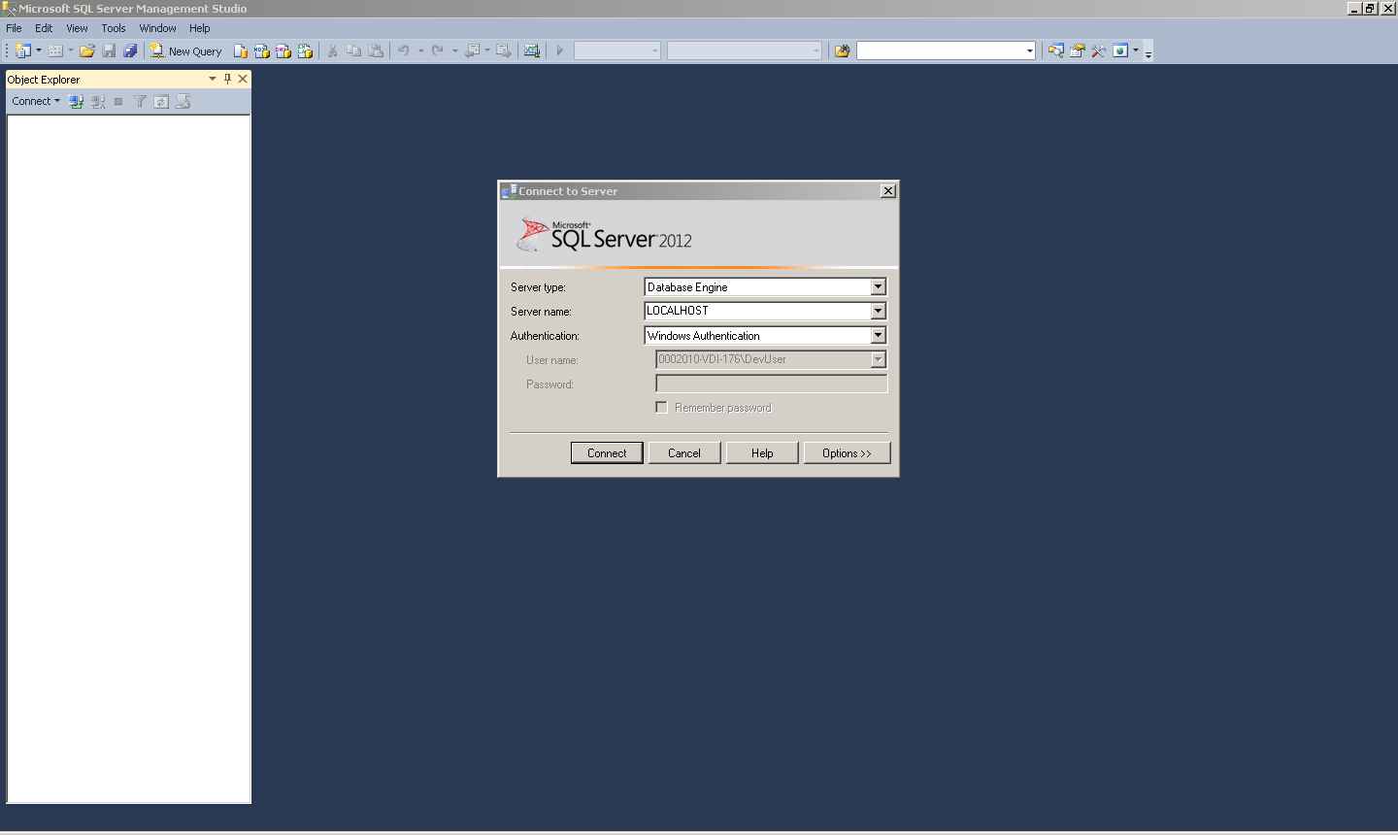

1. Connect to the local server by pressing the connect button.

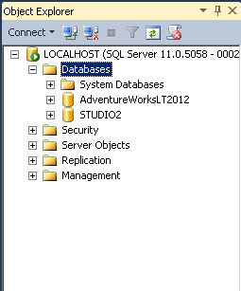

1. Expand the databases list and right click on the STUDIO2 database.

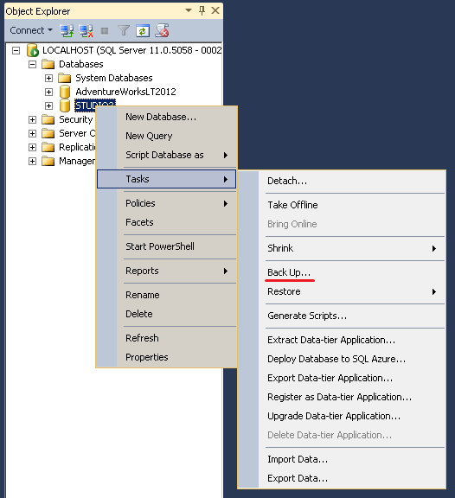

1. Hover over Tasks and select back up. 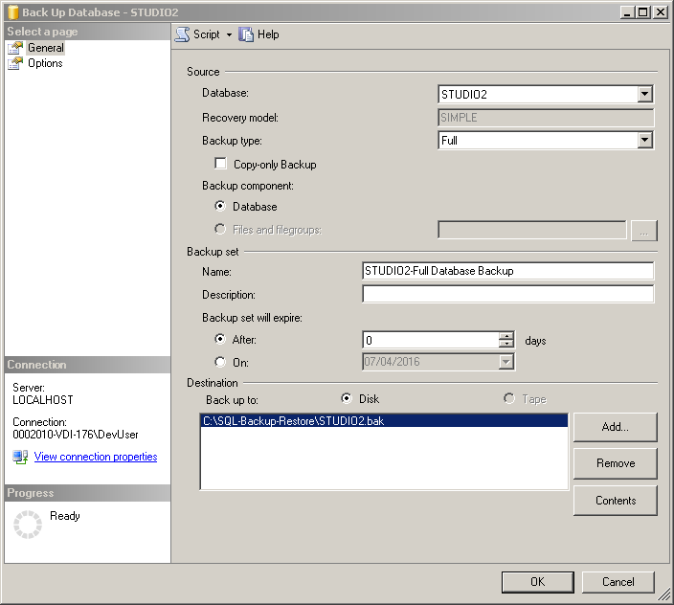

1. If the destination has not already been selected, press add. 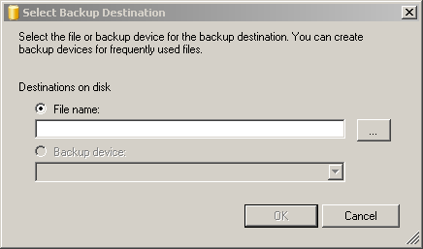
2. Then browse for the folder shown here:

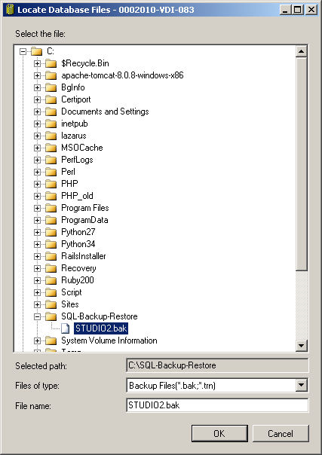

1. Then press Ok.

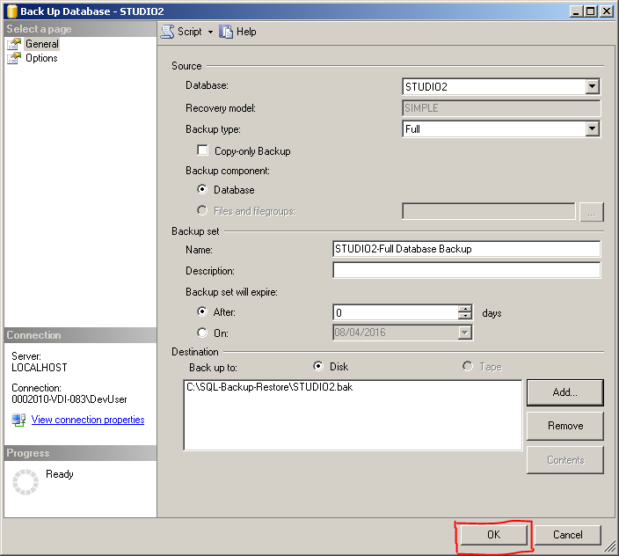

1. From that folder the backup can be copy and pasted out to a memory stick or sent in an E-Mail.

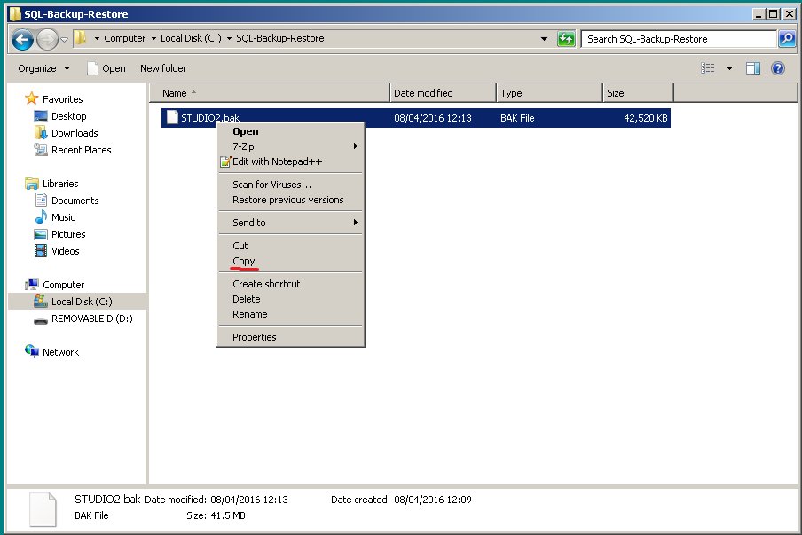

# Error Handling

I have attempted to safeguard against all common errors. I have provided message box pop-ups when there is an input error. I have also used try catch statement throughout to try and ensure that the program does not crash unexpectedly without informing the user of the problem. This means that the user can look up the error or report the error for bug fixing.

Examples:

If the search term entered does not produce results

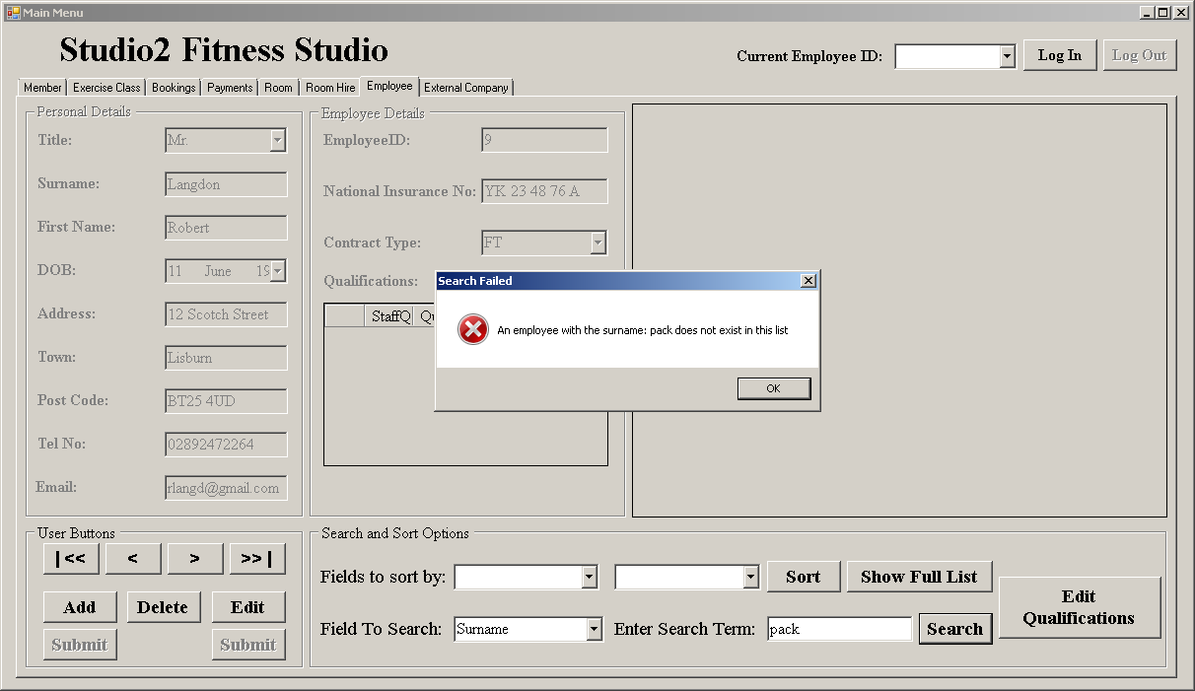

If a field was left blank

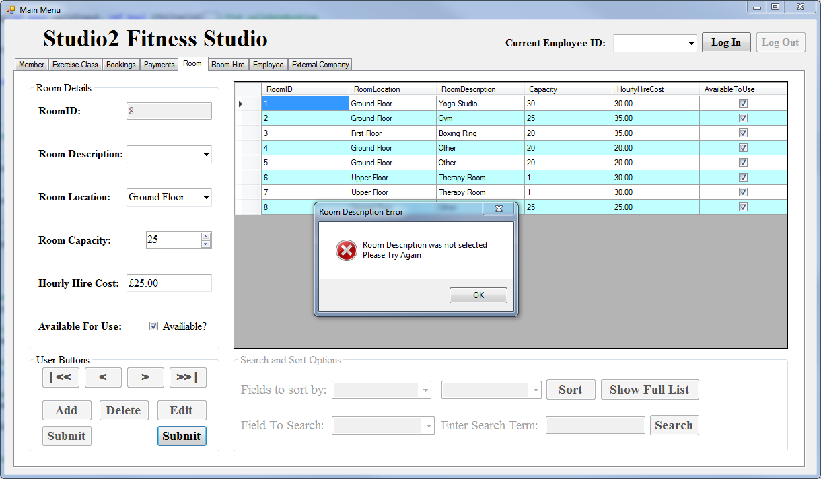

If you try and delete a record that has dependent records else where

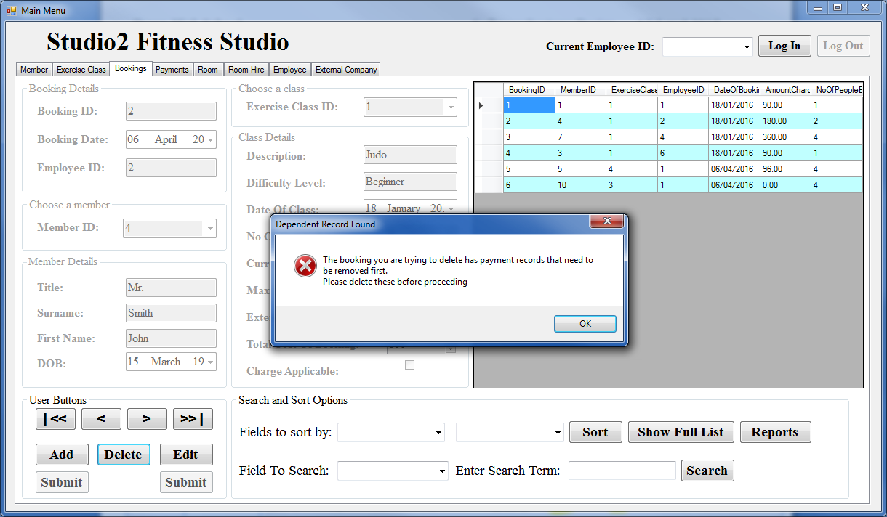

# Further Help and Support

This program was developed by Aaron Cunningham

More help/support can be obtained from me at

E-Mail: Studio2DevelopmentTeam@gmail.com

Telephone Number: 02890463275

Otherwise for:

Visual Studio: https://msdn.microsoft.com/en-us/library/wkfhs4sk(v=vs.90).aspx

SQL Server Management: https://msdn.microsoft.com/en-us/library/bb934498.aspx